Use Microsoft Word and Microsoft Excel to produce this document. Minus the directions, your document should resemble this document. Format the Microsoft Word document with one inch margins. Use ten point Palatino Linotype or Book Antiqua for your paragraph text font. Type the following lines using right text alignment and italics font style. Your line breaks will likely vary:
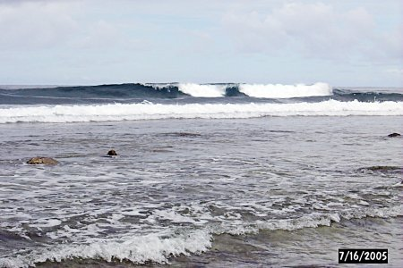
Waves are curious wonders,
Made of something so soft,
Small waves of water slip between the fingers of a baby,
Made of something so powerful,
Large waves of water destroy homes and lives,
Made of something so fearsome,
Men build dikes and seawalls to fend them off,
Made of something so playful that small boys in them frolic.

Insert the picture shown from http://www.comfsm.fm/~dleeling/ca/wave.jpg adjusting the picture and formatting it to match the layout above.
Create the following bulleted list. The bullet comes from the font family Wingdings. If you cannot determine how to get this bullet, at least create a bulleted list with the default bullet:

Uncle Ebenezer's Diabetes Preventative

- Four days of running
- Three healthy meals a day
- Two days of surfing
- One day of rest

Create the following data table using Excel. Create the chart seen below the table using an Excel XY scatter graph of the data in the table. When working on the chart, include the best fit trend line and the equation of the best fit line on the chart. Copy the table and chart into your Word document.

Depth (meters) | Speed (m/s)
1.0 | 3.1
1.5 | 3.8
2.0 | 4.4
2.5 | 4.9
3.0 | 5.9

Prepare the following PowerPoint slide using the same image as found in the Word document and the chart from the Excel document. The background, if available, is "nature."
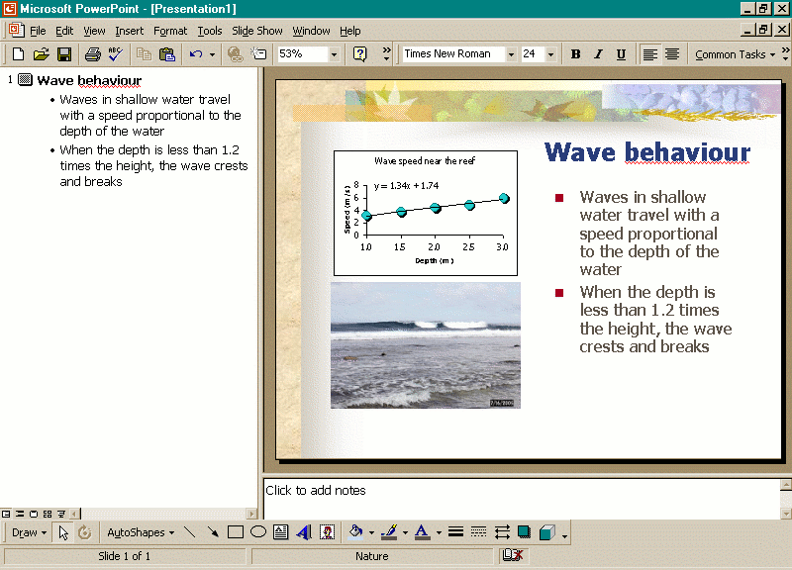
- What is the function of anti-virus software?
- What is the function of anti-spyware software?
- What is the function of a firewall on a computer?
- In the world of the Internet, what is a blog?
- In the world of the Internet, what is a wiki?
- During the introduction to the language for web pages invented by Tim Berners-Lee we wrote the tag <html>. For what is HTML an abbreviation?
- What is this?
