Measuring Body Fat Is Important for Determining Fitness
Weight alone is not a clear indicator of good health because it does not distinguish between pounds that come from body fat and those that come from lean body mass or muscle. Carrying too much fat is a condition called obesity, and puts a person at risk for many serious medical conditions including heart disease, diabetes and even certain forms of cancer. In fact, obesity contributes to at least half the chronic diseases in western society.
Not All Pounds Are the Same
Overweight means an excess of total body weight based on population averages for heights and body frame sizes. Athletes and very muscular people may be overweight, but that does not mean they are over fat. Obesity means an excess of body fat regardless of weight.
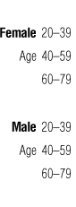 | 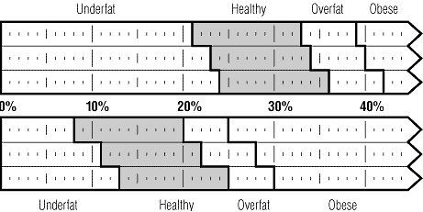

Your body fat percentage is simply the percentage of fat your body contains. If you are 150 pounds and 10% fat, it means that your body consists of 15 pounds fat and 135 pounds lean body mass (bone, muscle, organ tissue, blood and everything else).
A certain amount of fat is essential to bodily functions. Fat regulates body temperature, cushions and insulates organs and tissues and is the main form of the body's energy storage. The following table describes body fat ranges and their associated categories:

*General Body Fat Percentage Categories
*American Council on Exercise
Classification | Women (% fat) | Men (% fat)
Essential Fat | 10-12% | 2-4%
Athletes | 14-20% | 6-13%
Fitness | 21-24% | 14-17%
Acceptable | 25-31% | 18-25%
Obese | 32% plus | 25% plus

Knowing your body fat percentage can also help you determine if your weight loss goals are realistic. Remember, weight loss doesn't always mean fat loss.
Sources:
http://www.healthchecksystems.com/bodyfat.htm
http://www.tanita.com/consumer/health/measure/weightmgnt.html
Further information:
http://www.healthchecksystems.com/tbf.htm

