SC 130 Laboratory 06

Harry Skilling
Question
Is there a mathematical relationship between the drop height and the bounce height for a ball?

Hypothesis
There exists a mathematical relationship between the drop height and the bounce height for a ball.

Procedure
Drop the ball from five to ten different heights. For each drop measure the drop height in centimeters. Drop heights made by the students.

Measure the bounce height in centimeters for each drop height. The students are given a meter stick and different balls to choose with.

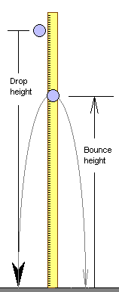
Data table

Rubber Ball
Drop Height (cm) | Bounce Height (cm)
150 | 99.6
120 | 78.2
100 | 68.4
90 | 66.4
80 | 57.4

Data Display and Data Analysis

Slope | 0.58
Intercept | 11.86493506

Conclusion
In the 8o’clock class, they are both given the same measurement equipments and little procedures on how to measure with and then afterwards they are assigned in teams in order to find the mathematical relationships, finding the measurements specifically including the table charts and the analysis. The relationship, based on the results fairly make a line in the chart which that’s mean there exists a mathematical relationship from the height bounces of the floor or even on the ground. There’s something has to do with the size of the ball. But of all the results each team may different results because they used different sizes of ball making the bounce high or low. But aside from that each team may have notice that there is a relationship of the height and where it bounces of.

