SC 130 Laboratory 05 • Name: RS Shotaro
This laboratory is the midterm practical examination laboratory. In this laboratory I intentionally provide considerably less guidance on the specifics of the procedure, table design, chart type, and analysis.

Hypothesis
There exists a mathematical relationship between the drop height and the bounce height for a ball.

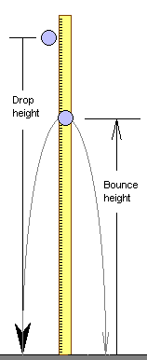

Procedure
- Drop the golf ball from five to ten different heights. For each drop measure the drop height in centimeters. You choose the drop heights.
- Measure the bounce height in centimeters for each drop height.

Data tables:
Drop#1 | Drop#2 | Drop#3 | Drop#4 | Drop#5 | MeanDrop | Height
126cm | 113cm | 88cm | 107cm | 131cm | 127.6cm | 170cm
128cm | 116cm | 93cm | 109cm | 133cm | 115.8cm | 150cm
125cm | 117cm | 91cm | 108cm | 135cm | 92.2cm | 120cm
130cm | 119cm | 94cm | 110cm | 134cm | 108.6cm | 140cm
129cm | 114cm | 95cm | 109cm | 138cm | 134.2cm | 160cm

Produce a table of drop heights and their corresponding bounce heights.

Make a chart appropriate to displaying the mathematical relationship between drop height and bounce height.

Data analysis
Slope= | 1.103331
Intercept= | 20.36667

Report the slope and intercept of a best fit line to your data. Does the data appear to be well modeled by a linear mathematical relationship? If not linear, is there a relationship? If you were given a drop height, could you calculate a bounce height?

Conclusion
In conclusion, there exists a mathematical relationship between the drop height and the bounce height for a ball. My crew and I have come up with the result for all the drop height and bounce height. Consequently we wrap up everything and we assume that the drop height and bounce height have a relationship, meaning they’re related by a linear mathematical relationship.

