Use 12 point Tahoma font to produce this one page document you hold in your hand.

Bold: Shopping List

- Lettered list:
- Quart jar of oil

Zinc oxide

Very bright paint

This is centered
Sphinx of black quartz,
Judge my vow.


Italics left justified: The public was amazed to view the quickness and dexterity of the juggler.

Right justified: Forsaking monastic tradition, twelve jovial friars gave up their vocation for a questionable existence on the flying trapeze.

Paintbrush picture, perfect square with thick purple border and a yellow center, floating on the right side of the page (embedded in the text):
Use Word to make the following table including the header with shading. Right justify the right column as shown:
Municipality | Population
Lelu | 2566
Malem | 1552
Utwe | 1130
Tafunsak | 2415

Matching:
A. _____ bold |  | i. Sphinx of black quartz, judge my vow.
B. _____ cursive |  | ii. Sphinx of black quartz, judge my vow.
C. _____ fantasy |  | iii. Sphinx of black quartz, judge my vow.
D. _____ italics |  | iv. Sphinx of black quartz, judge my vow.
E. _____ serif |  | v. Sphinx of black quartz, judge my vow.
F. _____ underline |  | vi. Sphinx of black quartz, judge my vow.

Produce the following table and pie chart using Excel:
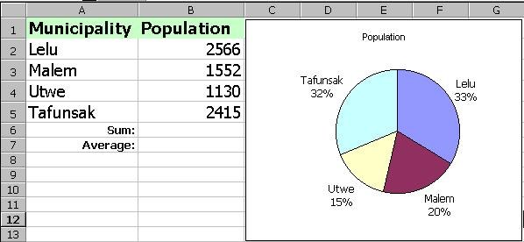

Calculate the total population of Kosrae: __________________
Calculate the average population per municipality: ________________

