Premna obtusifolia topwuk

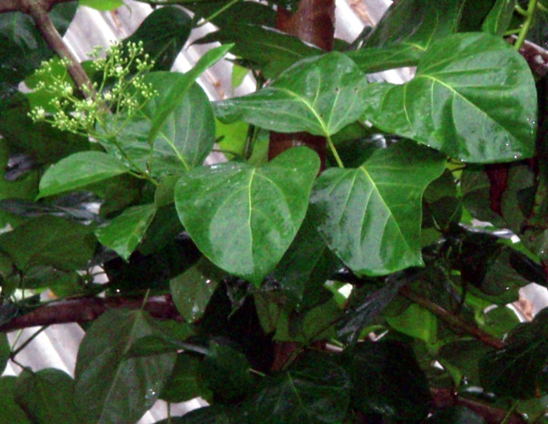

Family: Lamiaceae

Description: Woody shrub with ovate opposing leaves. Small white flowers, green and black berries.. Leaves are more openly arranged along branches than in Premna serratifolia, leaves are larger.

Location: Islandwide in distribution, spread by birds, often a first plant of disturbed terrain or burned areas.
Uses: Used in boiling hot water to treat flu. Place a pot of hot water with the leaves infused under a sheet, breathe in the steam while sweating. This form of treatment is known as umwulap.
Placing one young leaf on a boil to help bring it to a head. Change often. A boil is called umwpwos.

Scientific identifications are tentative. Spellings of Pohnpeian name are tentative.
Credits: College of Micronesia-FSM Pohnpei and National campuses, Totoa Fetalia-Currie, Bruno Barnabas, Yoster Kemillios, Jackson Phillip, Dana Lee Ling, and the students of SC/SS 115 Ethnobotany.

