A learning curve example from the real world
Experience: Attempt number | Learning: Rolling time (s)
1 | 0
2 | 0.5
3 | 0.9
4 | 2.6
5 | 8.5
6 | 3.6
7 | 5.8
8 | 4.8
9 | 12.3
10 | 7.9
11 | 8.3
12 | 10.4
13 | 9.3
14 | 10.6
15 | 10.1
16 | 16.6
17 | 12

"A learning curve is a graphical representation of the increase of learning (vertical axis) with experience (horizontal axis). The curve for a single subject may be erratic."

- Learning curve. (2013, June 11). In Wikipedia, The Free Encyclopedia. Retrieved 09:59, June 11, 2013, from http://en.wikipedia.org/w/index.php?title=Learning_curve&oldid=559313650

In a learning curve experiment a young girl was introduced to riding a RipStik for the first time. On her very first attempt to ride the RipStik she fell off immediately, a rolling time of zero seconds. On her second attempt she fell off in half a second. The attempts to ride are experience, the time during which she successfully rolled is the learning.

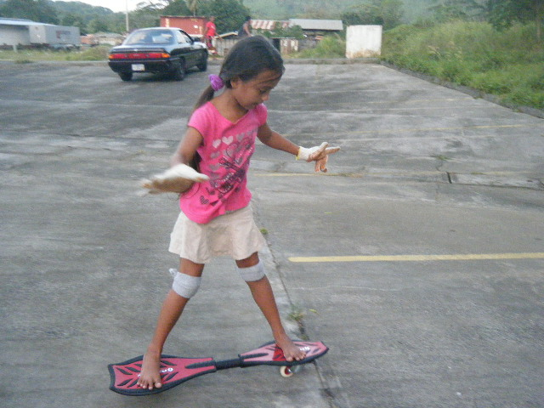
Use a spreadsheet to plot the data provided. Add a LOGARITHMIC trend line to the data. Spreadsheets will usually add a natural logarithm function.

1. Write out the logarithmic function keeping at least two decimal places.

2. Use the logarithmic function to calculate how long she is predicted to ride on her 20th attempt.

3. Use the logarithmic function to calculate the attempt on which she will ride for 14 seconds.

