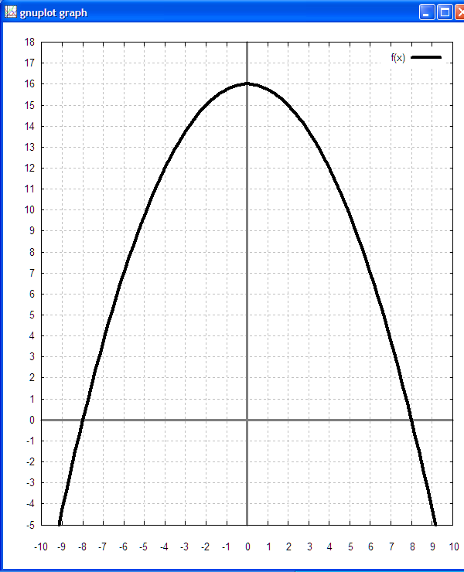
The Upward Bound high school pre-senior students were introduced to quadratics by rolling a marble on graph paper made of two sheets of 8.5x11 paper, the lower one rotated by 90°, and then sketching the arc of the marble. The desks in the class have a slight slope. With the vertex (0, k) on the y-axis, and the roots a distance ±r from the y-axis, the equation for this function is . In Gnuplot the function has to formed as f(x)=-k*(x*x)/s+k where s = r*r.

